Script

🌟 Definition
# Source: AI Source: Provided by: [Data Path: Persons Table -> ID Column: 1, Name_En Column: Motasem Essam] -> From: [ChatGPT] on [6/7/2026]
A Script is a small to medium-sized program written to automate tasks, execute commands, or control software behavior.
Scripts are usually interpreted and executed directly by a runtime environment rather than being compiled into standalone applications.

🎯 Simple Definition
# Source: AI Source: Provided by: [Data Path: Persons Table -> ID Column: 1, Name_En Column: Motasem Essam] -> From: [ChatGPT] on [6/7/2026]
Script = Code Written to Automate Tasks
Examples:
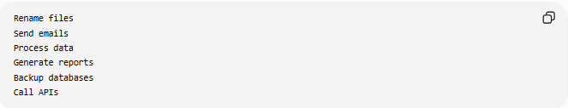
Rename files
Send emails
Process data
Generate reports
Backup databases
Call APIs

🧠 Real-World Analogy
# Source: AI Source: Provided by: [Data Path: Persons Table -> ID Column: 1, Name_En Column: Motasem Essam] -> From: [ChatGPT] on [6/7/2026]
Imagine a checklist for a personal assistant.
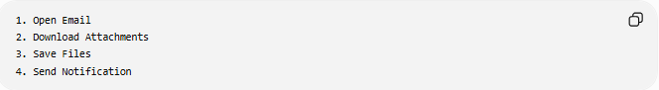
1. Open Email
2. Download Attachments
3. Save Files
4. Send Notification
The assistant follows the steps automatically.
A script works the same way for a computer.

🔄 How a Script Works
# Source: AI Source: Provided by: [Data Path: Persons Table -> ID Column: 1, Name_En Column: Motasem Essam] -> From: [ChatGPT] on [6/7/2026]
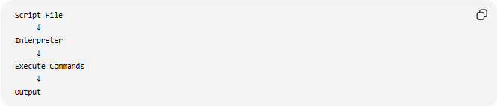
Script File
↓
Interpreter
↓
Execute Commands
↓
Output

📚 Example Script
# Source: AI Source: Provided by: [Data Path: Persons Table -> ID Column: 1, Name_En Column: Motasem Essam] -> From: [ChatGPT] on [6/7/2026]
PHP Script
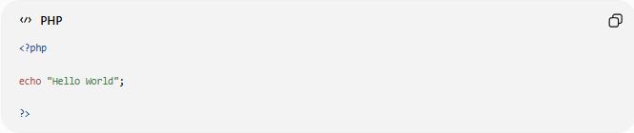
<?php
echo "Hello World";
?>
Output:
Hello World

Python Script
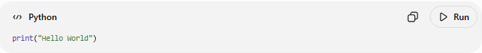
print("Hello World")
Output:
Hello World

JavaScript Script
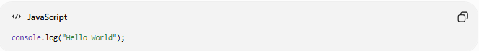
console.log("Hello World");
Output:
Hello World

🧩 Common Uses of Scripts

1️⃣ Automation
# Source: AI Source: Provided by: [Data Path: Persons Table -> ID Column: 1, Name_En Column: Motasem Essam] -> From: [ChatGPT] on [6/7/2026]
Automate repetitive tasks.
Example:
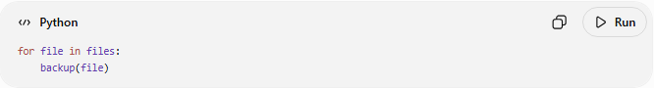
for file in files:
backup(file)

2️⃣ Data Processing
# Source: AI Source: Provided by: [Data Path: Persons Table -> ID Column: 1, Name_En Column: Motasem Essam] -> From: [ChatGPT] on [6/7/2026]
Read and manipulate data.
Example:
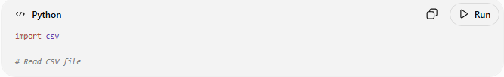
import csv
# Read CSV file

3️⃣ System Administration
# Source: AI Source: Provided by: [Data Path: Persons Table -> ID Column: 1, Name_En Column: Motasem Essam] -> From: [ChatGPT] on [6/7/2026]
Manage servers and operating systems.
Example:
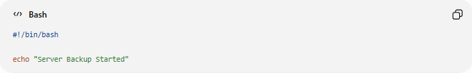
#!/bin/bash
echo "Server Backup Started"

4️⃣ Database Operations
# Source: AI Source: Provided by: [Data Path: Persons Table -> ID Column: 1, Name_En Column: Motasem Essam] -> From: [ChatGPT] on [6/7/2026]
Automate database tasks.
Example:
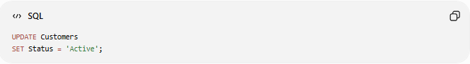
UPDATE Customers
SET Status = 'Active';

5️⃣ API Integration
# Source: AI Source: Provided by: [Data Path: Persons Table -> ID Column: 1, Name_En Column: Motasem Essam] -> From: [ChatGPT] on [6/7/2026]
Connect systems together.
Example:
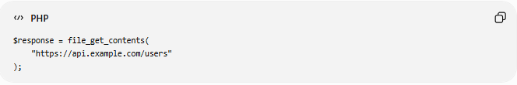
$response = file_get_contents(
"https://api.example.com/users"
);

6️⃣ Web Development
# Source: AI Source: Provided by: [Data Path: Persons Table -> ID Column: 1, Name_En Column: Motasem Essam] -> From: [ChatGPT] on [6/7/2026]
Add behavior to web pages.
Example:
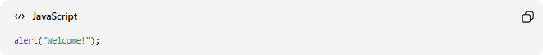
alert("Welcome!");

📂 Types of Scripts
# Source: AI Source: Provided by: [Data Path: Persons Table -> ID Column: 1, Name_En Column: Motasem Essam] -> From: [ChatGPT] on [6/7/2026]

Shell Script
Used in operating systems.
Example:
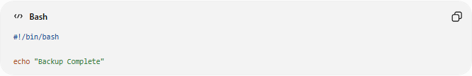
#!/bin/bash
echo "Backup Complete"

Python Script
Used for automation and data processing.
Example:
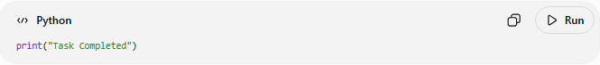
print("Task Completed")

PHP Script
Used for server-side web development.
Example:
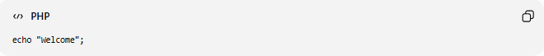
echo "Welcome";

JavaScript Script
Used in browsers and servers.
Example:
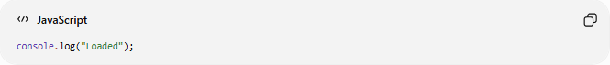
console.log("Loaded");

SQL Script
Used for database operations.
Example:
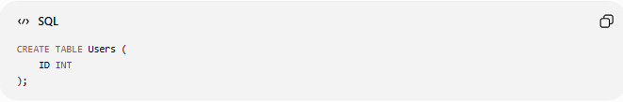
CREATE TABLE Users (
ID INT
);

📊 Script vs Program
# Source: AI Source: Provided by: [Data Path: Persons Table -> ID Column: 1, Name_En Column: Motasem Essam] -> From: [ChatGPT] on [6/7/2026]
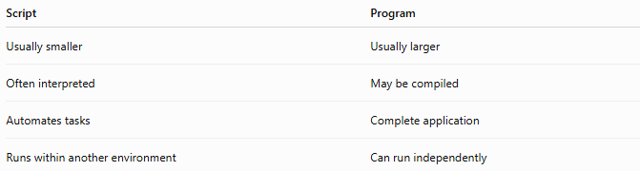
Script | Program
Usually smaller | Usually larger
Often interpreted | May be compiled
Automates tasks | Complete application
Runs within another environment | Can run independently

Example
Script:
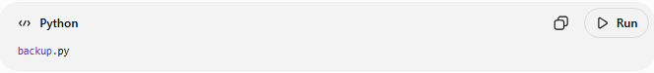
backup.py
Performs a backup task.

Program:
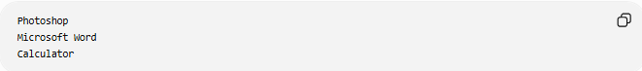
Photoshop
Microsoft Word
Calculator
Complete software applications.

📊 Script vs Code
# Source: AI Source: Provided by: [Data Path: Persons Table -> ID Column: 1, Name_En Column: Motasem Essam] -> From: [ChatGPT] on [6/7/2026]
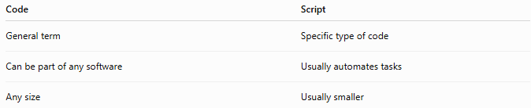
Code | Script
General term | Specific type of code
Can be part of any software | Usually automates tasks
Any size | Usually smaller

Relationship
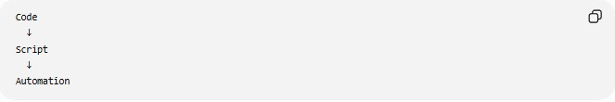
Code
↓
Script
↓
Automation
A script is a type of code.

🌍 Real-World Examples
# Source: AI Source: Provided by: [Data Path: Persons Table -> ID Column: 1, Name_En Column: Motasem Essam] -> From: [ChatGPT] on [6/7/2026]
Daily Backup Script
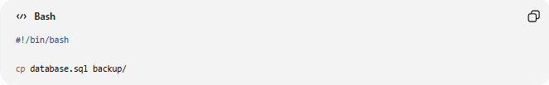
#!/bin/bash
cp database.sql backup/
Copies a database backup automatically.

Email Script
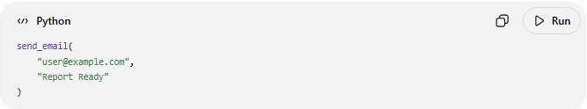
send_email(
"user@example.com",
"Report Ready"
)
Sends emails automatically.

API Script
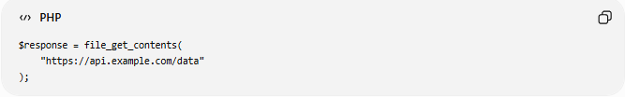
$response = file_get_contents(
"https://api.example.com/data"
);
Fetches data from an API.

🛠️ Popular Scripting Languages
# Source: AI Source: Provided by: [Data Path: Persons Table -> ID Column: 1, Name_En Column: Motasem Essam] -> From: [ChatGPT] on [6/7/2026]
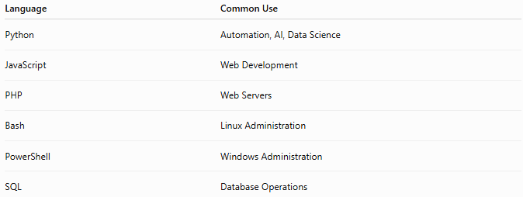
Language | Common Use
Python | Automation, AI, Data Science
JavaScript | Web Development
PHP | Web Servers
Bash | Linux Administration
PowerShell | Windows Administration
SQL | Database Operations

✅ Advantages of Scripts
# Source: AI Source: Provided by: [Data Path: Persons Table -> ID Column: 1, Name_En Column: Motasem Essam] -> From: [ChatGPT] on [6/7/2026]
- Automate repetitive tasks
- Save time
- Easy to write
- Fast execution for simple tasks
- Improve productivity

❌ Disadvantages of Scripts
# Source: AI Source: Provided by: [Data Path: Persons Table -> ID Column: 1, Name_En Column: Motasem Essam] -> From: [ChatGPT] on [6/7/2026]
- May be slower than compiled programs
- Harder to manage when very large
- Runtime errors occur during execution
- Depend on interpreters

🧠 Simple Analogy
# Source: AI Source: Provided by: [Data Path: Persons Table -> ID Column: 1, Name_En Column: Motasem Essam] -> From: [ChatGPT] on [6/7/2026]
Think of a script as a written checklist.
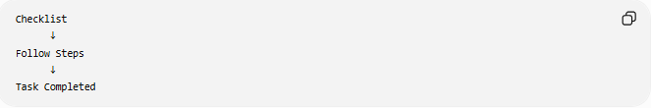
Checklist
↓
Follow Steps
↓
Task Completed
Similarly:
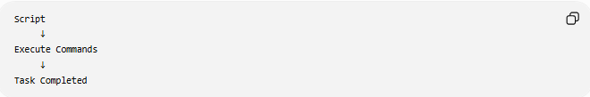
Script
↓
Execute Commands
↓
Task Completed

🧭 Summary
# Source: AI Source: Provided by: [Data Path: Persons Table -> ID Column: 1, Name_En Column: Motasem Essam] -> From: [ChatGPT] on [6/7/2026]
A Script is a type of code designed to automate tasks, execute commands, or control software behavior. Scripts are commonly written in languages such as Python, JavaScript, PHP, Bash, and PowerShell. They are typically smaller than full applications and are often used for automation, system administration, data processing, API integration, and database operations. A script is essentially a set of instructions that performs a specific task automatically.

